Lab:01

Experiment Name: Implementation of basic gates and universal gates.

**Equipment:**

1. Trainer board
2. Bread board
3. IC
4. Connecting wire

**Theory:**

Logic gates are electronic circuits which perform logical functions on one or more inputs to produce one output. There are seven logic gates. When all the input combinations of a logic gate are written in a series and their corresponding outputs written along them, then this input/ output combination is called Truth Table. Some gates and their working is explained here.

**Diagrams and pin diagrams:**

1. **AND Gate**

AND gate produces an output as 1, when all its inputs are 1; otherwise the output is 0. This gate can have minimum 2 inputs but output is always one. Its output is 0 when any input is 0.

Diagram:



Pin diagram:

[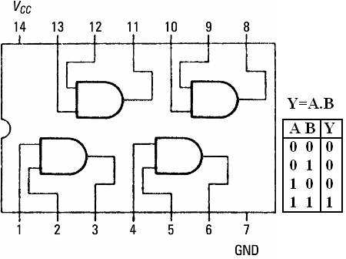](https://sites.google.com/site/amtmttl/st2/IC7408.PNG?attredirects=0)

**IC 7408**

1. **OR Gate**

OR gate produces an output as 1, when any or all its inputs are 1; otherwise the output is 0. This gate can have minimum 2 inputs but output is always one. Its output is 0 when all input are 0.

Diagram:

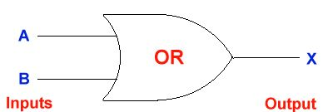

Pin diagram:

[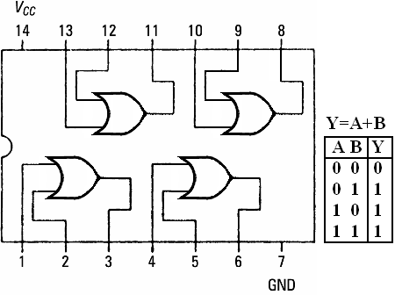](https://sites.google.com/site/amtmttl/st2/IC7432.PNG?attredirects=0)

IC 7432

**3)NOT Gate**

NOT gate produces the complement of its input. This gate is also called an INVERTER. It always has one input and one output. Its output is 0 when input is 1 and output is 1 when input is 0.

Diagram:

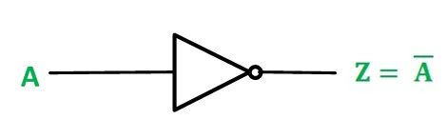

Pin diagram:

[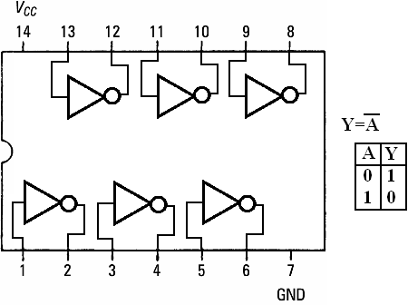](https://sites.google.com/site/amtmttl/st2/IC7404.PNG?attredirects=0)

IC 7404

**4)NAND Gate**

NAND gate is actually a series of AND gate with NOT gate. If we connect the output of an AND gate to the input of a NOT gate, this combination will work as NOT-AND or NAND gate. Its output is 1 when any or all inputs are 0, otherwise output is 1.

Diagram:

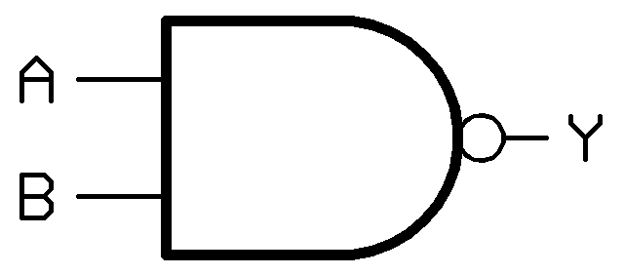

Pin diagram:

[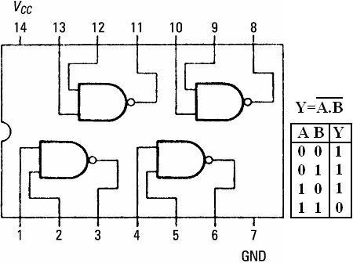](https://sites.google.com/site/amtmttl/st2/IC7400.png?attredirects=0)

**IC 7400**

**5)NOR Gate**

NOR gate is actually a series of OR gate with NOT gate. If we connect the output of an OR gate to the input of a NOT gate, this combination will work as NOT-OR or NOR gate. Its output is 0 when any or all inputs are 1, otherwise output is 1.

Diagram:

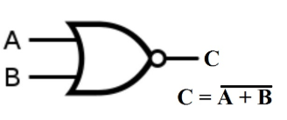

Pin diagram:

[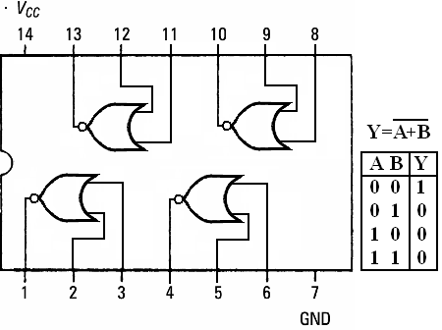](https://sites.google.com/site/amtmttl/st2/IC7402.PNG?attredirects=0)

**IC 7402**

Results:  
NOT Gate: When logic 1 is applied to one of NOT gate of 7404 IC, then output becomes zero.  
When input LED is ON (RED), the output LED become OFF (Green) vice versa.  
OR Gate: The output of an OR gate is a 1 if one or the other or both of the inputs are 1, but a 0 if  
both inputs are 0. When One or the other or Both of the input LEDS are ON (RED Light), then  
output LED is ON(RED) otherwise Output LED is OFF(Green Light)  
AND Gate: The output of an AND gate is only 1 if both its inputs are 1. For all other possible  
inputs the output is 0.When both the LEDS are On, then output LED is ON (RED Light)  
otherwise Output LED is OFF.  
NOR Gate: The output of the NOR gate is a 1 if both inputs are 0 but a 0 if one or the other or  
both the inputs are 1.  
inputs are both 0 and both 1.  
Conclusion:

By doing this experiment we learned that any Boolean expression can be realized using NOT, AND, OR, NAND,NOR,